BCS Community Health Center
Patient Name:
MR# DOB:
Annual Diabetes Foot Exam

History of plantar ulceration? Yes No Date ______________

Monofilament Exam: + = can feel the 10 gram nylon filament - = cannot feel the 10 gram nylon filament

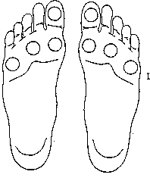
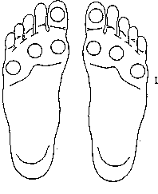
Right Left
Right Left
Right Left
Draw in:

Callus

Pre-Ulcer

Ulcer

Vibration Right Left Right Left Right Left

Foot Exam Results Normal / Abnormal Normal / Abnormal Normal / Abnormal

Referral Date ________________/___________________/_________________
BCS Community Health Center
Annual Diabetes Foot Exam
Patient Name:
MR# DOB:

History of plantar ulceration? Yes No Date ______________
Monofilament Exam: + = can feel the 10 gram nylon filament - = cannot feel the 10 gram nylon filament
Right Left
Draw in:

Callus

Pre-Ulcer

Ulcer
Monofilament Exam Completed

by:_________________________

Risk Category
0 No Loss of protective sensation
1 Loss of protective sensation with no
weakness, deformity, callus, pre-ulcer,
or history of ulceration
2 Loss of protective sensation with
weakness, deformity, pre-ulcer, or
callus but no history of ulceration
3 History of plantar ulceration/charcot
foot

Risk Categories Low High
Low = intact sensation, pedal
pulse present, no severe
deformity, no foot ulcer, no
amputation

High = loss of sensation, pedal
pulse absent, severe deformity,
history of foot ulcers, and prior
amputation

Vibration Right Left

Foot Exam Results Normal Abnormal

Referral Date_________________________________________________

